Onboarding AWS Environments as Dynatrace AWS Connections
Internal only do not share any content (as is) from this blog outside Dynatrace
Published: October 30, 2025
Updated: December 10, 2025
Authors: Kobi Biton, Principal Tech. Product Manager, Data Acquisition, AWS |
Isaac Vallhonrat, Principal Product Architect, AWS | Grawolinki Marek, Senior Software Engineer
Target Audience: Dynatrace Sales Engineers, Customer Support Managers, Architects, Consultant, Field CTOs, any other who find this topic interesting J
The new AWS Cloud Platform Monitoring (preview) is now close to General Availability. We, in cloud product management, learn/ed a lot from our (preview) customers and our internal adopters. Feedback for onboarding is generally positive yet; we are told that that:
a/Duty separation principle into our onboarding processes should be improved
b/We should support the onboarding of their AWS environments via CLI/GitOPS
Ultimately allow them to integrate the process into their own GitOPS internal processes. We also learn that many Dynatrace customers practice strong duty-separation mentality, where the Dynatrace Admin has full control only on the Dynatrace environments. A separated team (a.k.a platform team/SRE team) is the sole administrator of the AWS Environments, often creating a friction during onboarding of AWS Environments for Dynatrace Monitoring.
While we have designed to address both areas at a later stage of the product (more on that on the next blog). We understand that we must work backwards from our customers and integrate a duty separation feature into our current supported onboarding methods.
The preview (first) supported onboarding path is a UX Wizard implemented on our 3rdGen Settings App. You can evaluate this journey here.

So, What’s new?
We have introduced enhancements which makes the duty separation easier for customers:
- Our documentation prerequisites section has been enhanced to include a fine-grain AWS permissions requirements, moreover the CloudFormation Templates are publicly available, allowing DT Admins to share those with the AWS Admins.
- We have added an action button that allows the Dynatrace Admin to share the CloudFormation Deployment (deep) Link with the AWS Admins, allowing them to deploy the stack and complete the Connection creation using their cloud identity, it looks like this:
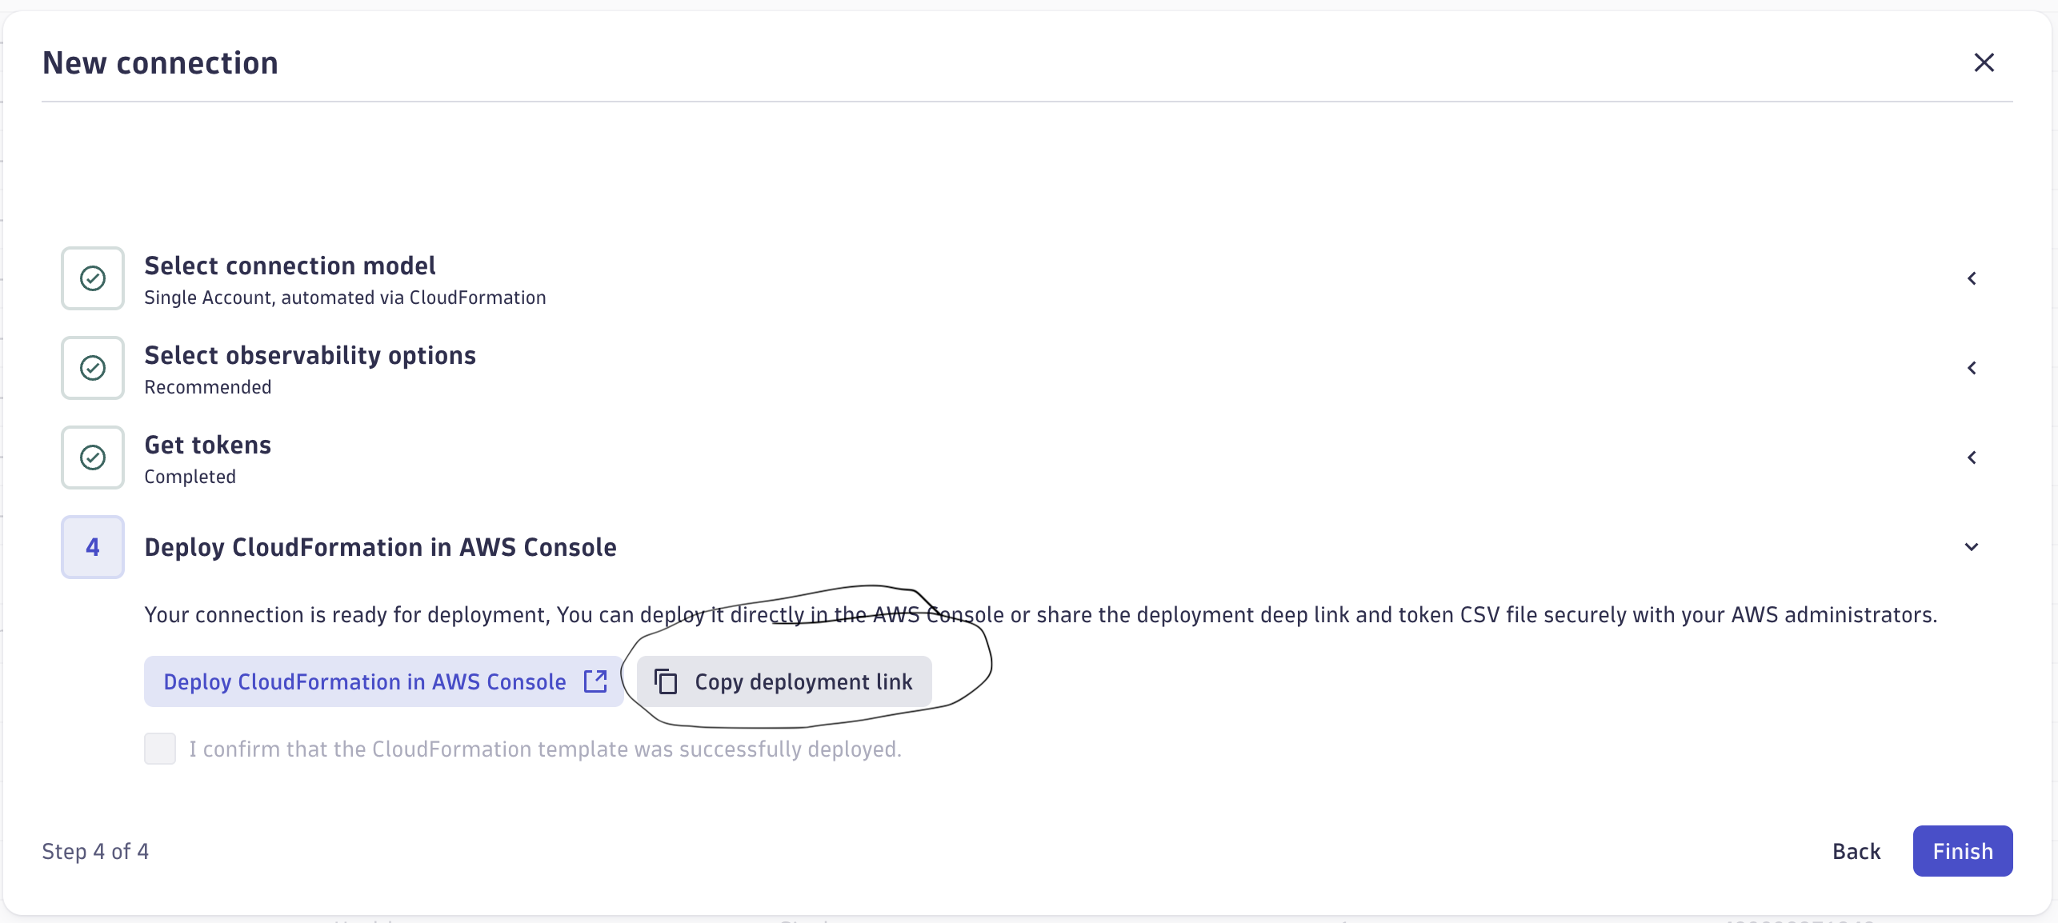
This feature unlocks the customer duty-separation enhancement ask, DT Admin creates the monitoring configuration, AWS Admin deploys the AWS Resources and completes the connection. Those 2 workflows are de-coupled, allowing the AWS Admins to complete the connection creation at a later stage.
Mind that at the preview release we have completely migrated our Cloud APIs to 3rdGen, therefore only Platform Tokens (for service users) are supported.
The token generation step looks like this:
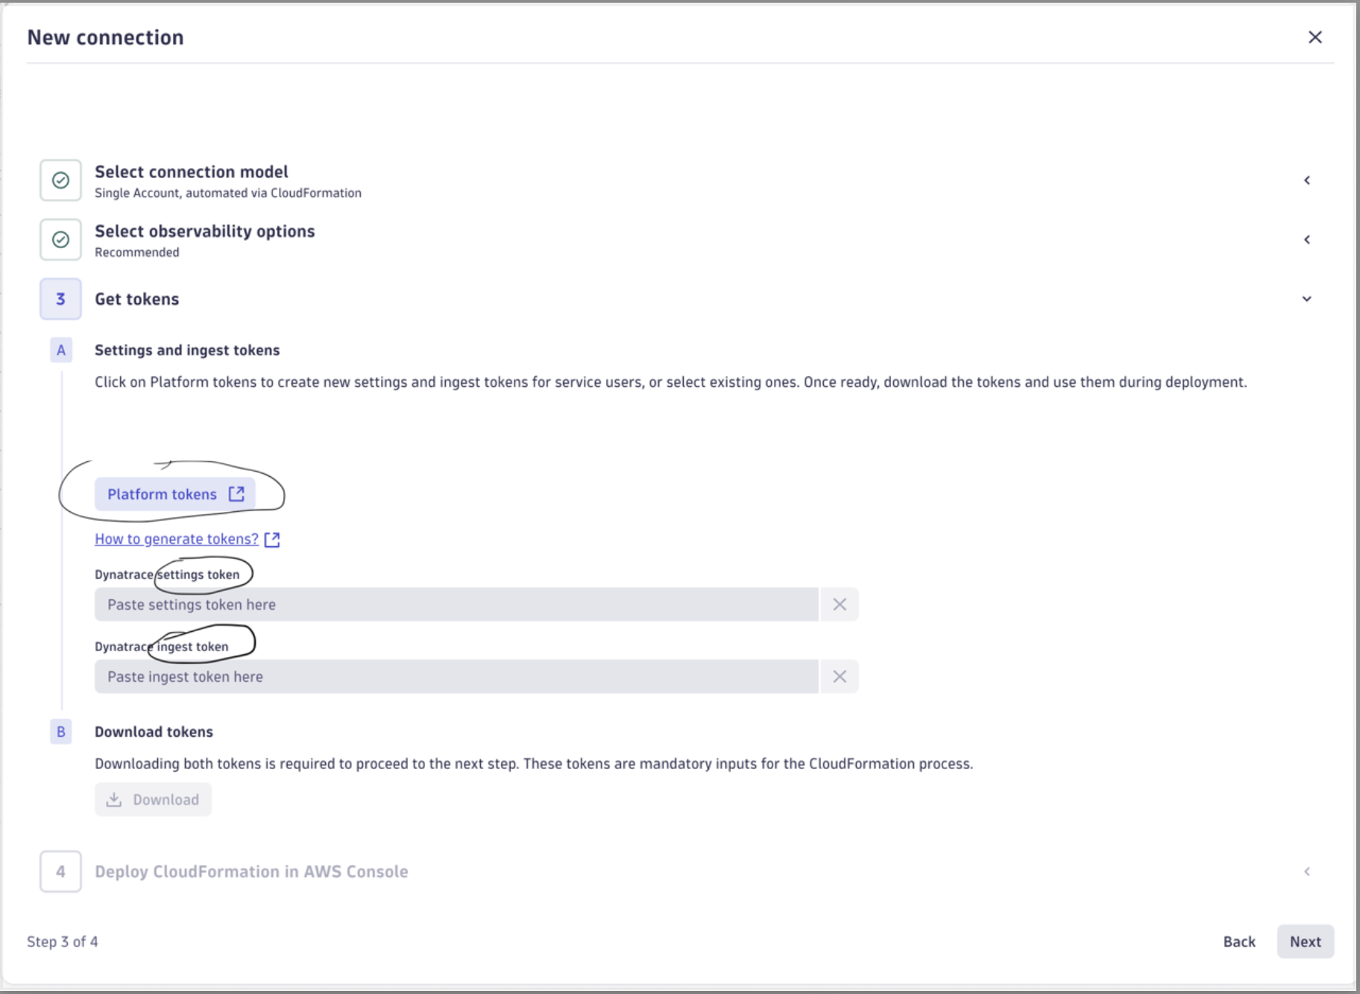
The second ask is to showcase an ability to get the same outcome of using the Wizard, by using Command Line Interface, which is considered the Platform Teams comfort zone.
It is beyond this blog to delve deep into the onboarding design and upcoming additional supported paths/Journeys. We will just mention that the IaC underlying technology we use as well as our API-First approach combined, allows us to introduce CLI/GitOPS onboarding Journeys using a strong common baseline.
Here’s how to onboard your AWS Account into a Dynatrace AWS Connection using the CLI:
Note: It is recommended to test this using a prod trial tenant environment to get the customer experience
Prerequisites
- An AWS Account with the proper IAM permissions and access
- A Dynatrace Tenant, preferability prod trial
- Prerequisites section to be completed for AWS And Dynatrace
- Create Dynatrace Platform Tokens for service users, Step 3 only
- Amazon Linux Bastion host with internet access, “AWS CLI” installed, (Attached IAM Role should allow the CloudFormation creation)
- Configure the AWS CLI
AWS configure #only set the region you plan to deploy the cloudformation on (our example uses us-east-2)

Creating the Monitoring Configuration
Start a CLI session on your bastion:
- Download this bash script , unzip it and run the below:
chmod +x awsmonv3.sh && ./awsmonv3.sh

- Provide all the requested inputs, example input for my script run:
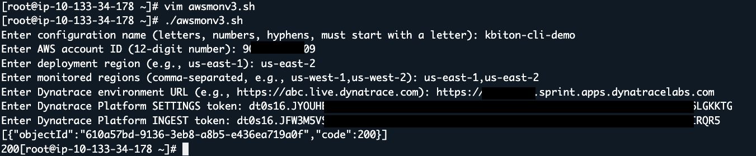
Record the <objectId>, we will need it for the next step.
If your API call failed, validate that the tokens, AWS Account ID, Tenant env URL are all valid

Creating the AWS Connection
Note on CloudFormation Versions: To the end of this blog, v0.8.4 is the latest prod version. Soon we will release a major version: v1.0.0, you can track the latest one here.
pDtApiToken - use your Settings Token
pDtIngestToken – use your ingest token
pMonitoringConfigId – use the returned objectId
wget -O da-aws-activation_v0.8.4.yaml https://dynatrace-data-acquisition.s3.amazonaws.com/aws/deployment/cfn/v0.8.4/da-aws-activation.yaml && \
aws cloudformation deploy \
--region us-east-2 \
--stack-name kbiton-cli-demo \
--template-file da-aws-activation_v0.8.4.yaml \
--capabilities CAPABILITY_NAMED_IAM \
--parameter-overrides pDynatraceUrl=https://[EnvironmentID].sprint.apps.dynatracelabs.com pMonitoringConfigId=ObjectId pDtApiToken=dt0s16.JYOUHEF7.**************************** pDtIngestToken=dt0s16.JFW3M5VS.************LEIIIHDFTJU4UMBCDJ5LIRQR5 pDtLogsIngestEnabled=TRUE pDtLogsIngest
s=us-east-1,us-east-2

Desired result

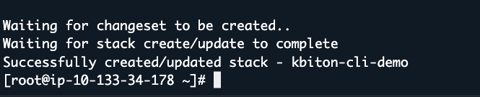
Head over to the Clouds Application, in the next few minutes telemetry and AWS resources should appear.
The Deployment failed? Look at the troubleshooting section here.

What should I expect next?
The product management team is working with our Eng. Teams to complete tests on CLI onboarding, publishing this onboarding journey as a supported one on our public documentation.
For now, experiment yourself and maybe with your customer with the proper disclaimer that this has not been fully productized 😊
The product management team is collaborating with Engineering to test CLI onboarding and will update our public documentation when it's officially supported. For now, feel free to try it—just let customers know it isn't fully productized yet.
Feedback is welcomed, feel free to reach out to @Biton, Kobi and share it.

